NoSQL Assignment:

Name: Goutham Kumar R

Roll.no: D20015

Q1. Create database praxis

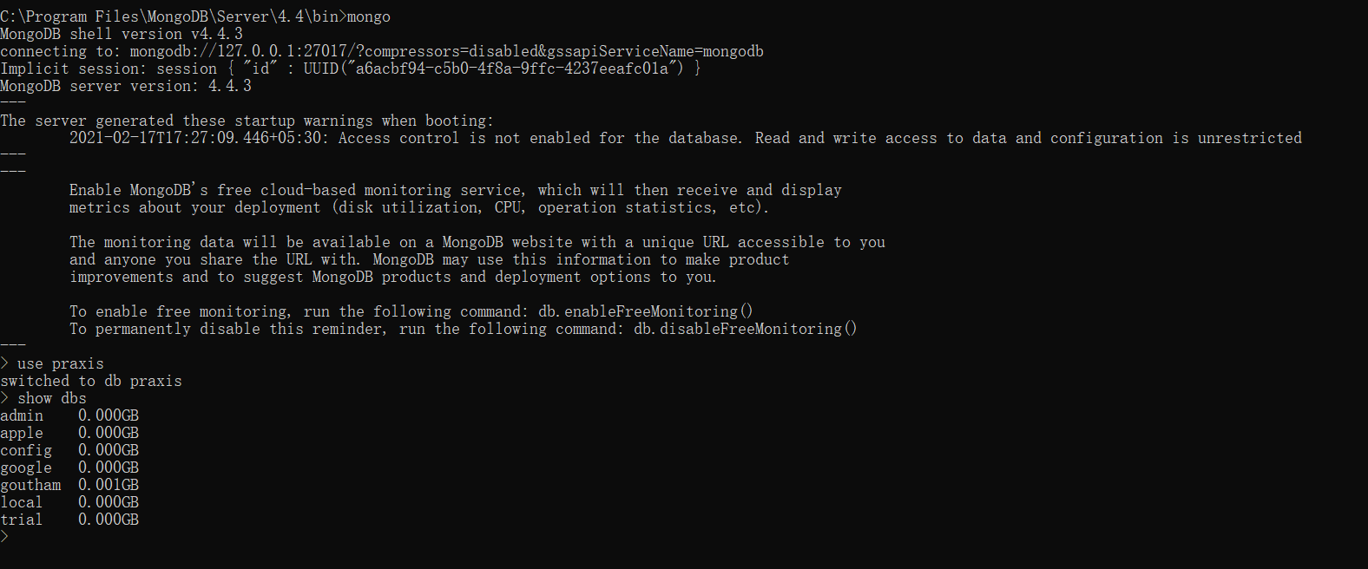

Q2 Create collection restaurant

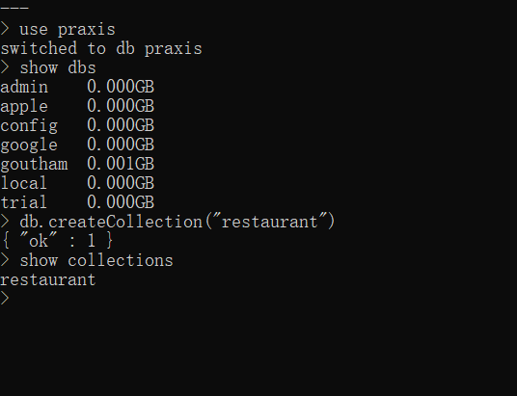

Q3. Insert below json in collection restaurant and then add at least 4 more in same collection…

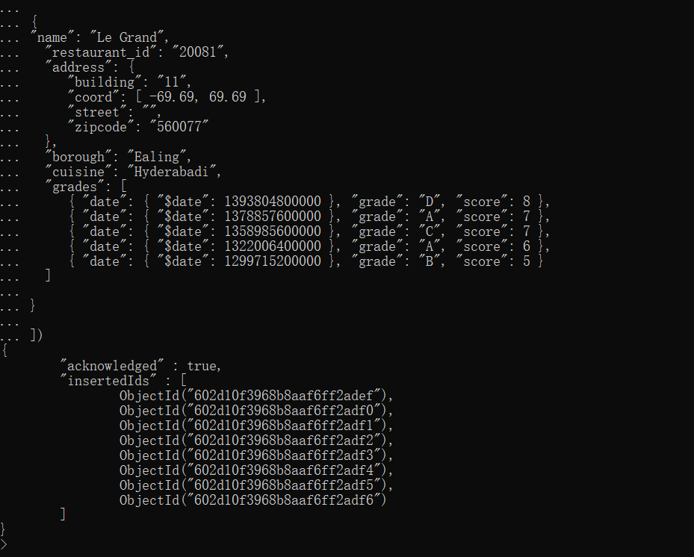

Added 8 records

Q4. Write a MongoDB query to display all the documents in the collection restaurant

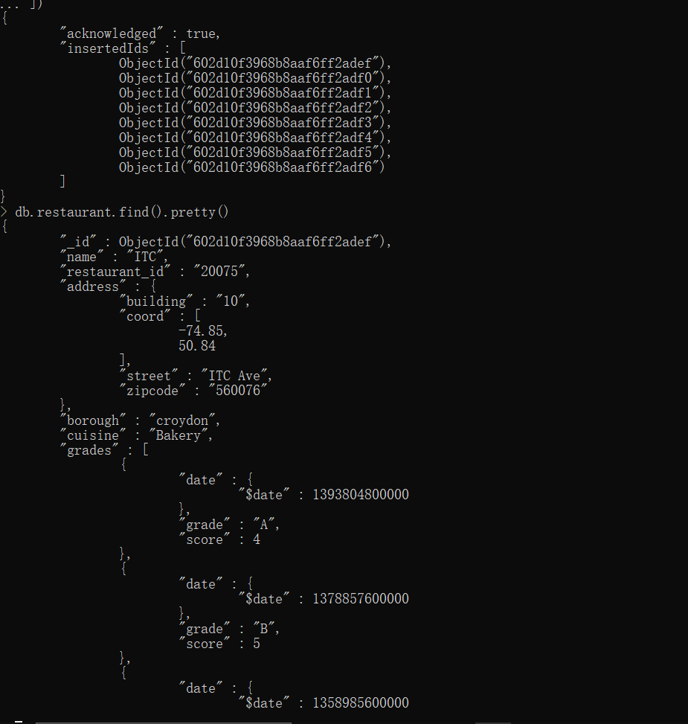

Q5. Write a MongoDB query to display the fields restaurant_id, name, borough and cuisine for all the documents in the collection restaurant.

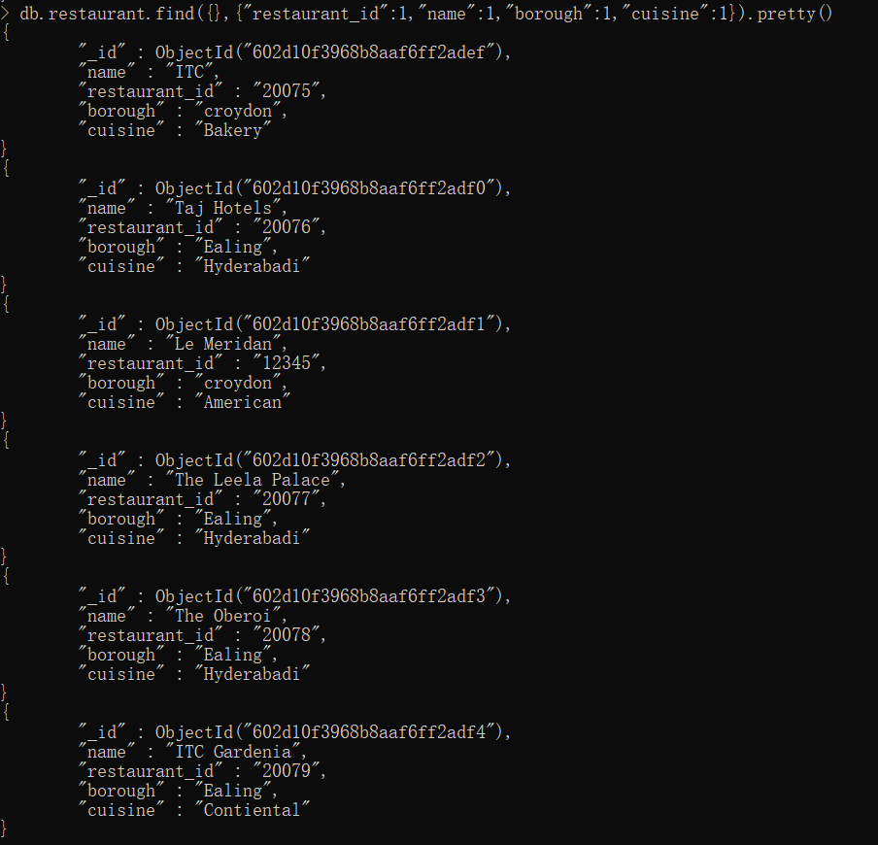

Q6. Write a MongoDB query to display the fields restaurant_id, name, borough and cuisine, but exclude the field “_id” for all the documents in the collection restaurant.

Note: Since in the question, we have asked to mask the objected , I have masked objectid

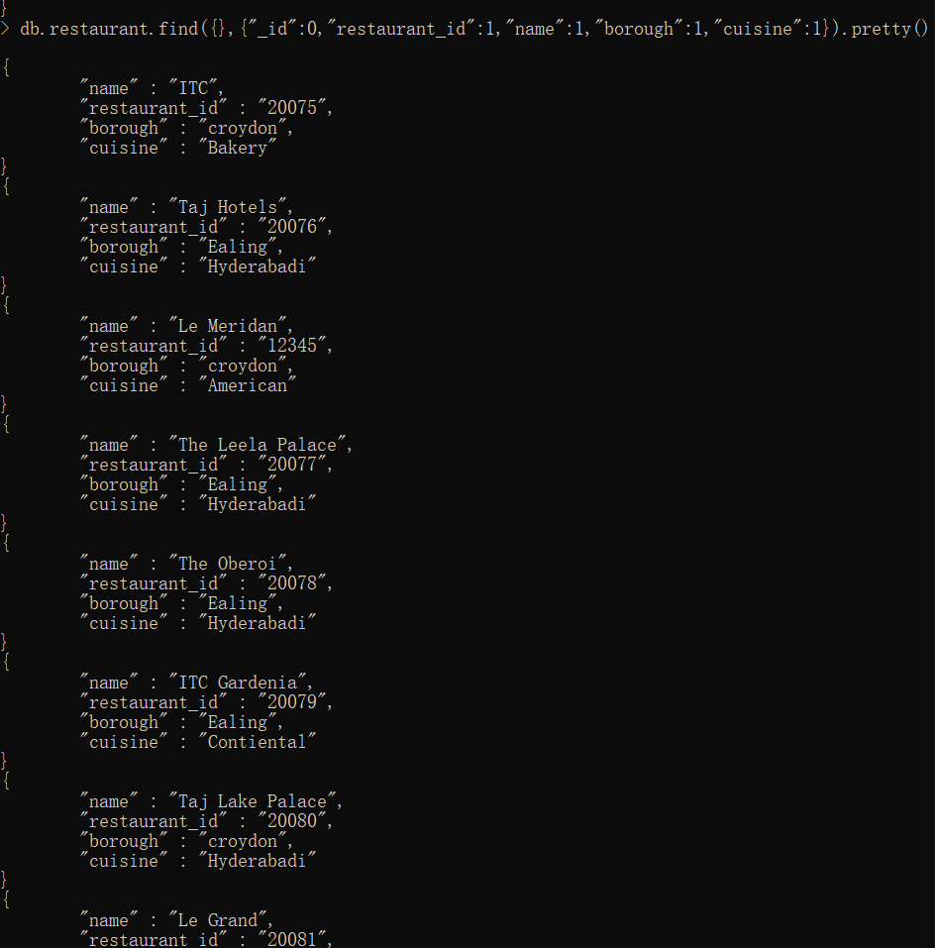

Q7. Write a MongoDB query to display the fields restaurant_id, name, borough, zip code and grade, but exclude the field _id for all the documents in the collection restaurant.

Note: Since in the question, we have asked to mask the objectid , I have masked objectid

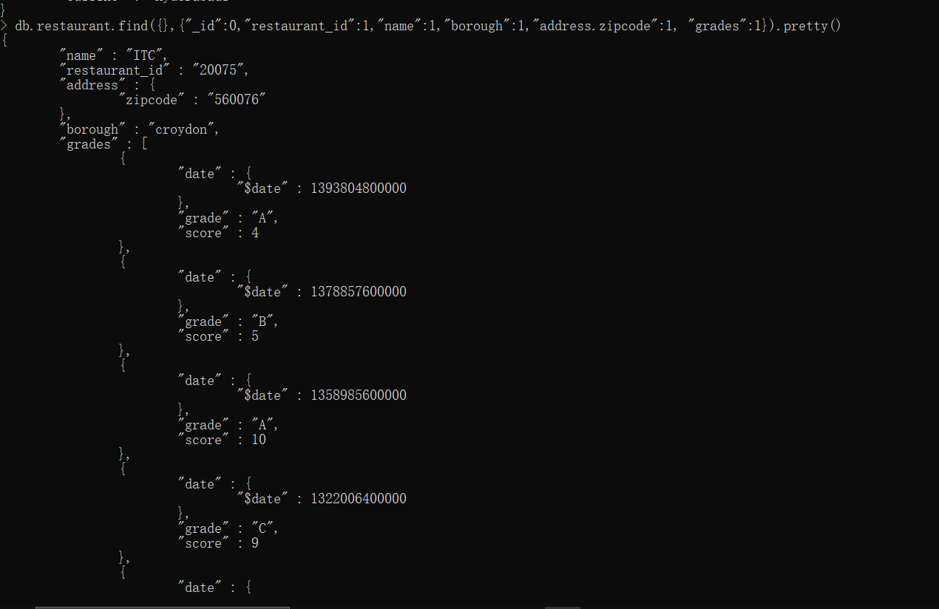

Q8. Write a MongoDB query to display all the restaurant which is in the borough croydon.

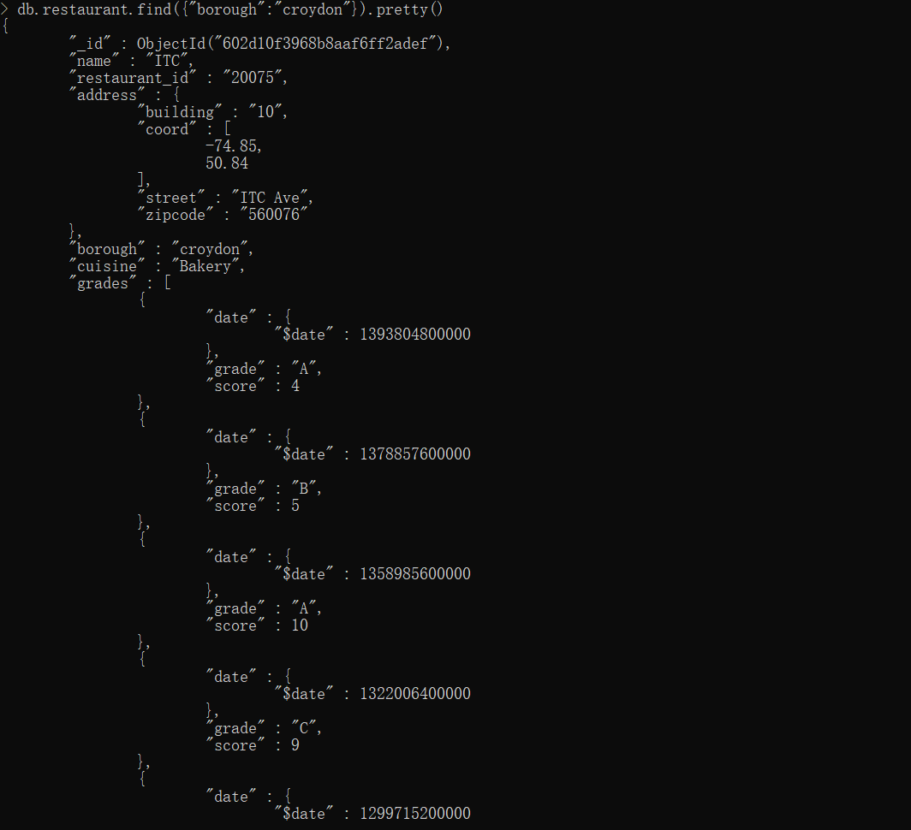

Q9. Write a MongoDB query to display the first 5 restaurant which is in the borough Ealing.

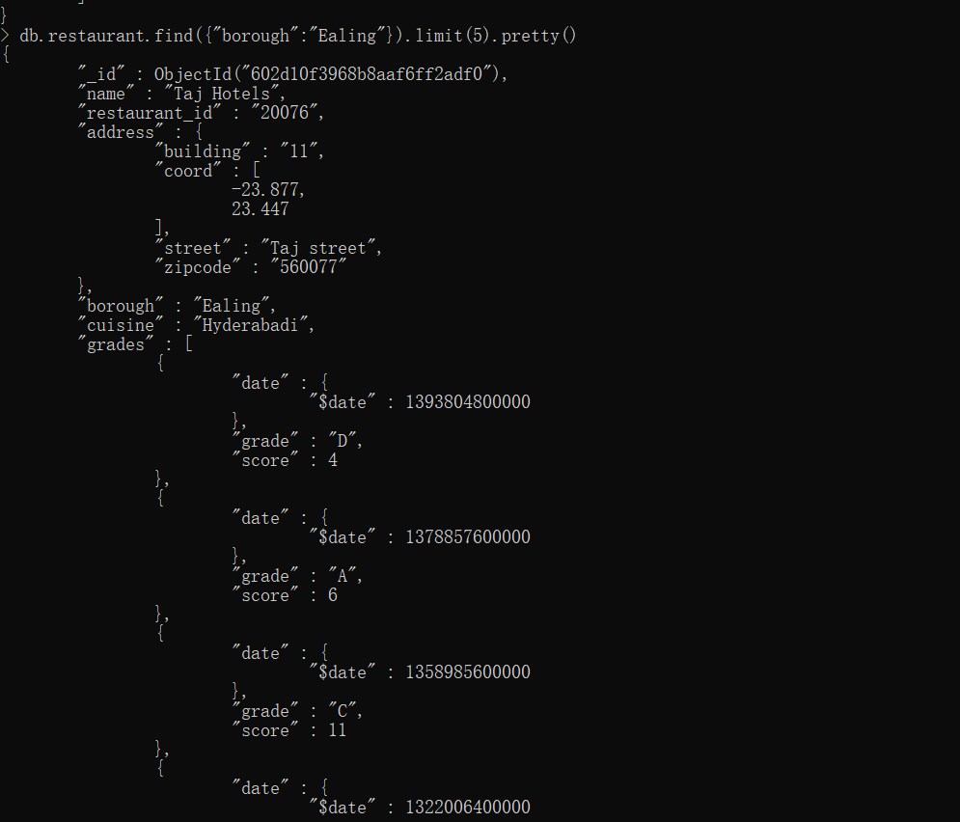

Q10. Write a MongoDB query to display the next 1 restaurants after skipping first 2 which are in the borough Eagling.

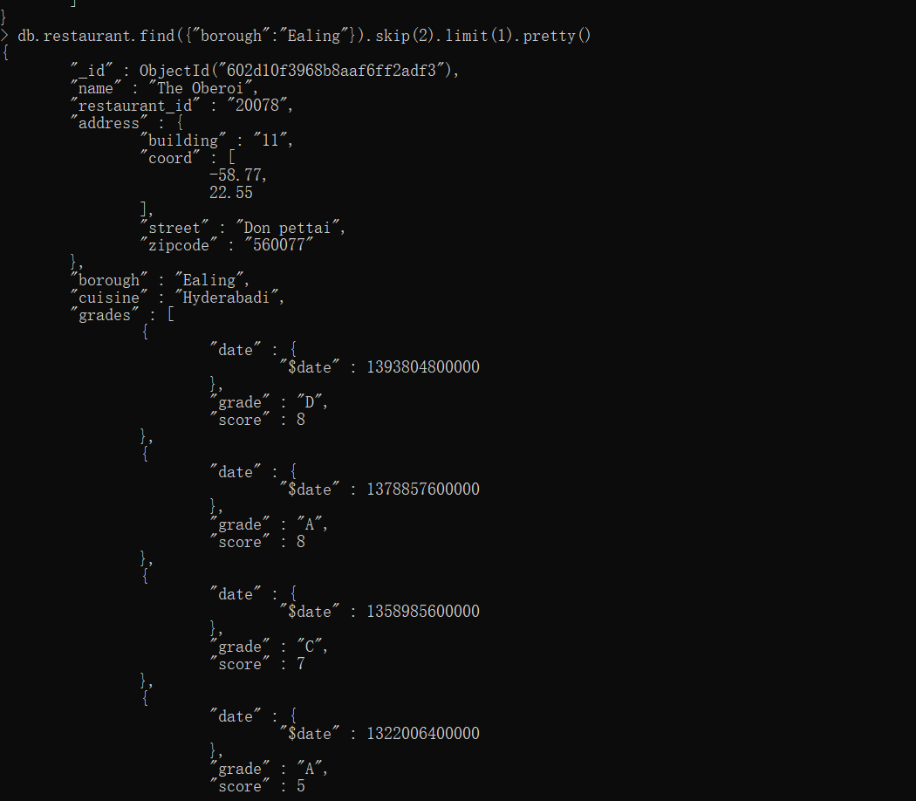

Q11. Write a MongoDB query to find the restaurants who achieved a score more than 9.

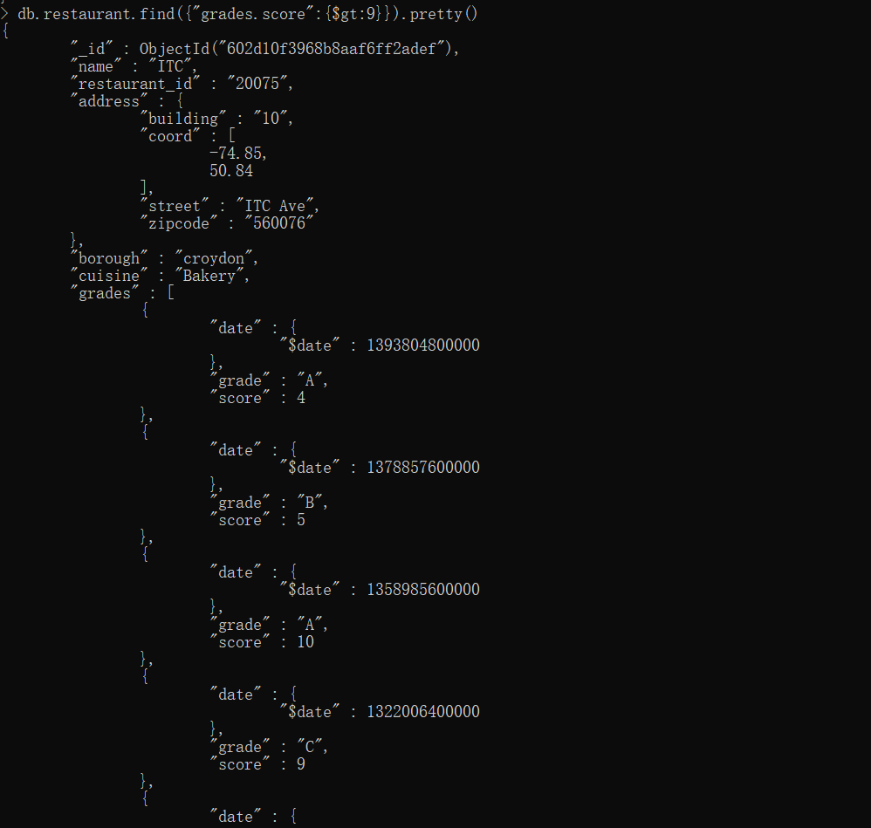

Q12. Write a MongoDB query to find the restaurants that achieved a score, more than 4 but less than 10.

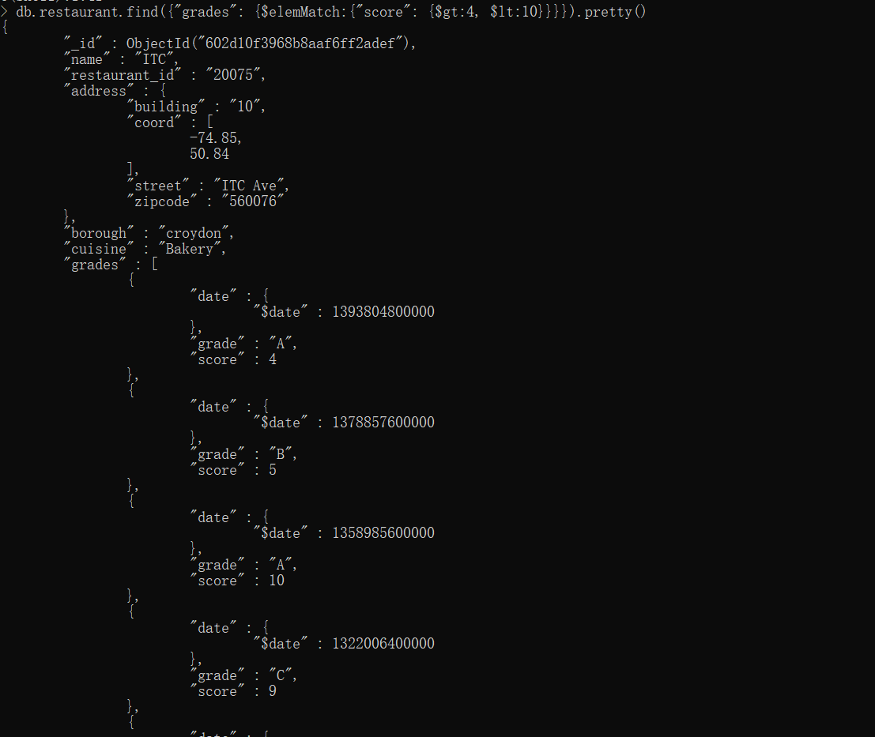

Q13. Write a MongoDB query to find the restaurants which do not prepare any cuisine of 'American ' and achieved a grade point 'A' not belongs to the borough croydon. The document must be displayed according to the cuisine in descending order.

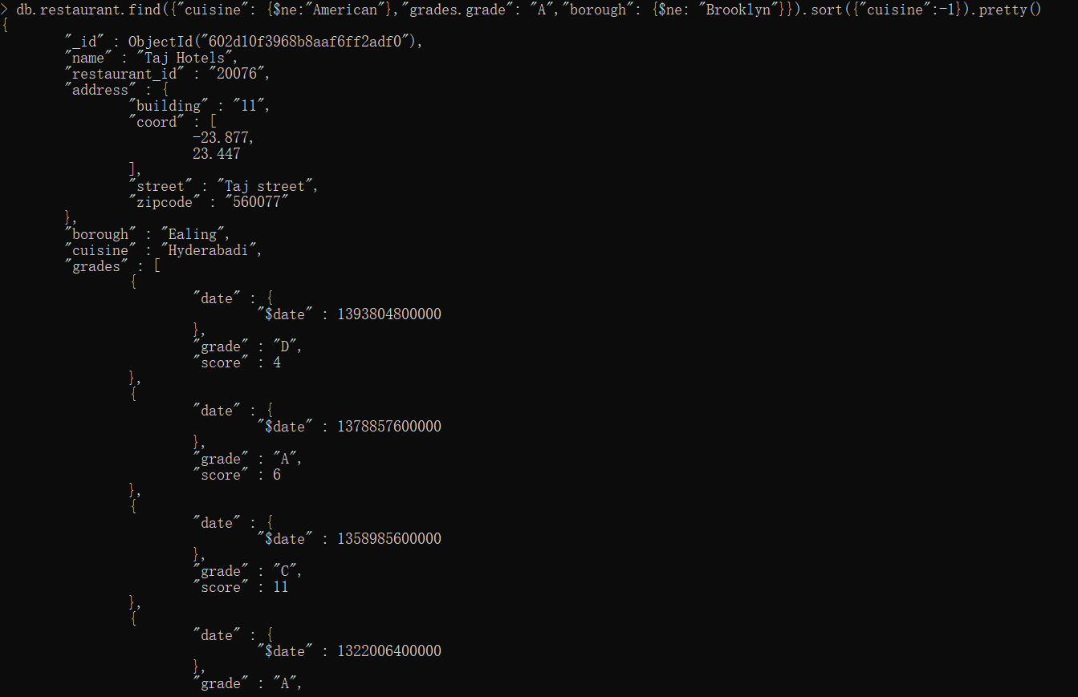

Q14. Update document zipcode of all documents to 560070

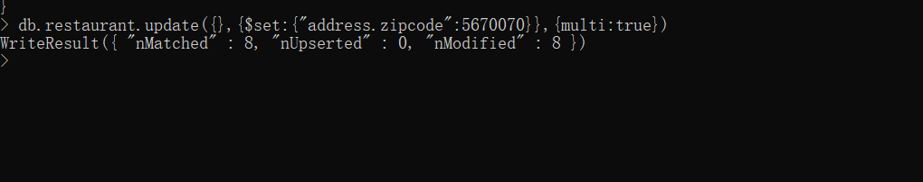

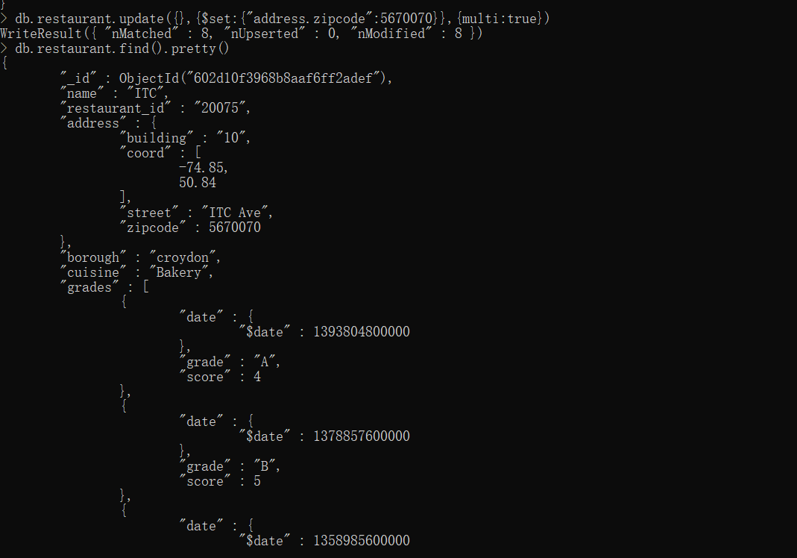

Q15.Update document zipcode to 987456 of document where borough is Croydon.

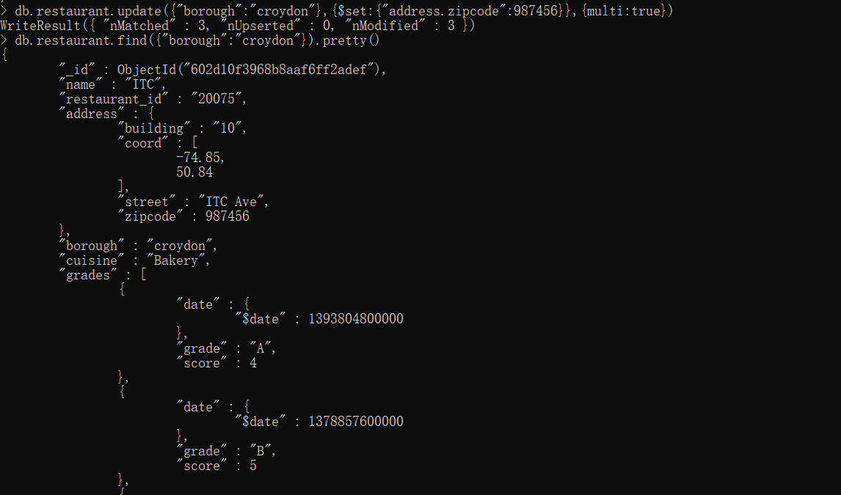

Q16. Remove document where restaurant id is ‘12345’

Note: Since there was no document to match the criteria, no document was dropped.

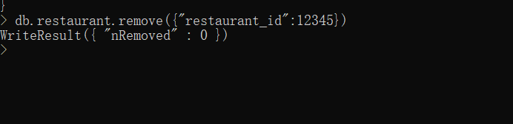

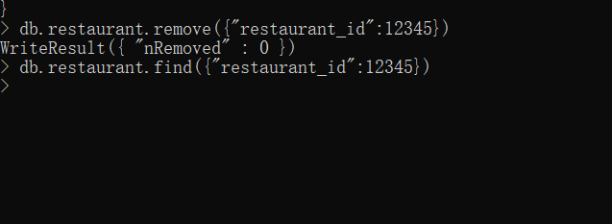

Q17. Remove sub document grades from document where zipcode is 987456.

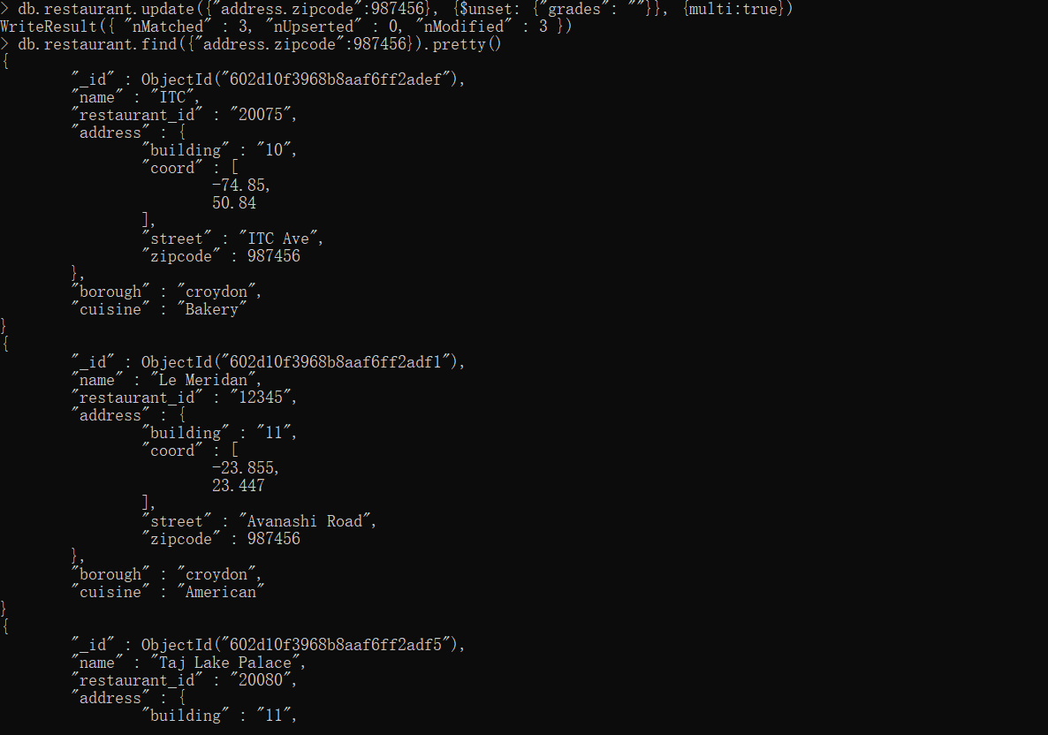

Q18. Create index on collection restaurant on column restaurant_id enforcing uniqueness

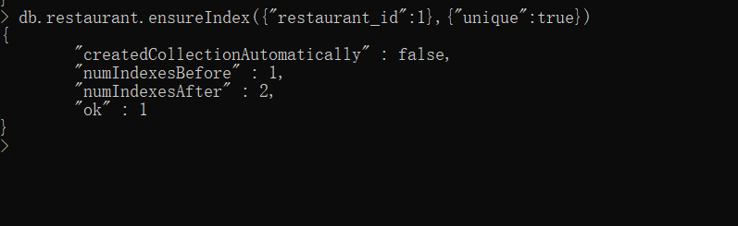

Q19. Create compound index on any 2 keys of collection restaurants.

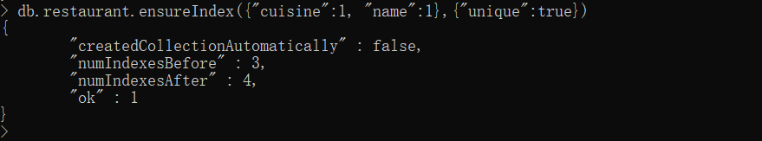

Q20. Drop database praxis.

